Adopt-A-Future: Gambela Primary School, Kakuma Refugee Camp, Kenya

The United Nations Association, Westchester (NY) chapter has pledged to raise $30,000 (which will be matched 100%) to support the Gambela Primary School in Kakuma Refugee Camp (Kenya) to:
- Build one new classroom;
- Improve water and sanitation facilities;
- Provide desks, school uniforms, and school bags for 40 students over 10 years;
- Help with textbooks and pay teachers’ salaries for one classroom for 10 years;
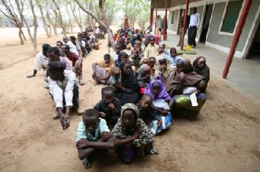
- Support special teacher training, in order to teach children who have gone through severe trauma, such as these refugee children.
Children at Gambela Primary School need a classroom where they can learn

The Kakuma Refugee Camp was established in the early 1990s and is managed by the Kenyan government and the Kenyan Department of Refugee Affairs in conjunction with the UN High Commissioner for Refugees (UNHCR). The camp has over 190,000 residents and 17 primary schools. Gambela Primary school has over 3,300 students, of whom over 40% are girls. The current teacher: student ratio is 1:95. If we reach our goal of $30,000, generous donors will match all the funds! Please donate what you can!

Students attend outside assembly at Gambela Primary School

Please join us for a fund-raiser for Human Rights Day on December 7, 2017. The event will be held at Apricots and Honey Wine and Spirits in Mount Vernon from 6 to 9 pm. It is a great opportunity to network and learn more about the program You can buy tickets or donate HERE.

You can also donate at: http://www.unausa.org/programs/adopt-a-future. Indicate UNA Westchester on the form, so the donation will reach the Gambela Primary School students. At this same link, you can download a form to donate by regular mail.

Everyone at UNA Westchester and the Gambela Primary School thanks you for your kind support!

